CAMPUS CLUB EVENT MANAGER
@CREATIVITY THINK (9483175986/7019689991)

ABSTRACT:
Campus Club Event Manager is a web-based platform designed to streamline event management for college clubs, youth groups, and student societies. The system allows users to discover upcoming events, RSVP, receive reminders, join group discussions, and track activities through a personalized dashboard. Administrators can create events, approve RSVPs, moderate chats, and analyze engagement trends. Built with Django and Django Rest Framework for backend logic, and React with Redux and socket.io for real-time interactions, the application ensures an efficient, interactive, and collaborative environment for campus communities..

INTRODUCTION OF THE PROJECT:
Student organizations often rely on fragmented communication channels such as WhatsApp groups, social media posts, or manual lists to manage events. This leads to confusion, missed notifications, and ineffective participation tracking. The Campus Club Event Manager solves these problems by offering a unified platform for event creation, RSVP management, reminders, and group chats. With real-time updates and centralized dashboards, the system enhances coordination, engagement, and communication across student communities..

PROJECT OBJECTIVES:

• Provide a platform for managing club and campus events
• Allow users to RSVP, receive reminders, and join group chat discussions
• Enable administrators to add events and track participation metrics
• Offer real-time chat functionality using socket.io
• Provide dashboards for both users and administrators
• Improve communication and engagement in college clubs
• Ensure organized record-keeping for events and attendance
• Support structured reporting for administrators

PROBLEM OF THE STATEMENT:
Student clubs and societies typically manage events manually, which results in poor communication and scattered participation data. Announcements may be missed, RSVP lists are hard to maintain, and feedback channels lack structure. Without a centralized system, administrators face difficulty in tracking engagement and moderating interactions. Campus Club Event Manager eliminates these issues by offering automated reminders, digital RSVPs, real-time chat, and a unified analytics dashboard to enhance coordination and involvement..

MOTIVATION OF THE PROJECT:
• To streamline event management for student organizations
• To provide an organized RSVP system with accurate participant tracking
• To enhance communication using real-time chat
• To ensure students never miss important event notifications
• To offer administrators insights into event engagement and feedback
• To create a unified digital platform for campus activities
• To replace scattered, manual, and inconsistent communication methods

BLOCK DAIGRAM OF PROJECT:

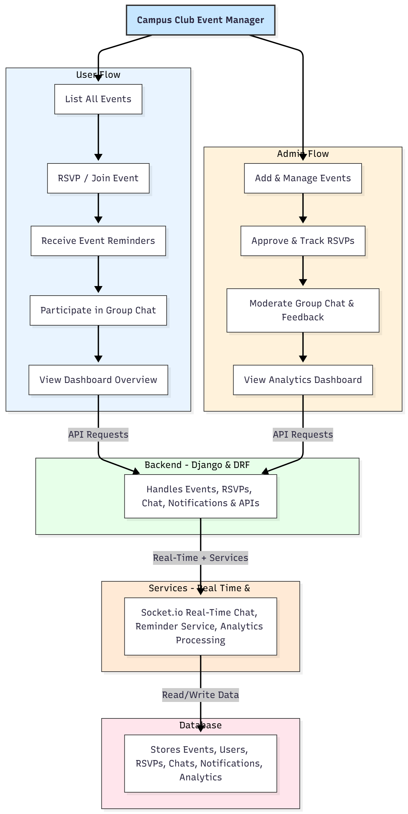

WORKING OF THE PROJECT:
The system begins with administrators creating new events and publishing them on the platform. Users access the event list, RSVP to join, and automatically receive notifications or reminders before the event begins. The real-time chat module enables participants to communicate and share updates instantly. Administrators oversee RSVPs, monitor chat activities, and filter feedback where necessary. Both user and admin dashboards display insights about event participation, engagement levels, and activity history. All data—including chats, RSVPs, notifications, and analytics—is processed by backend services and stored securely in the database for reporting and management..

SOFTWARE REQUIREMENT:
- Backend:
  - Python 3.x
  - Django
  - Django REST Framework
  - SQLite/PostgreSQL
- Frontend:
  - Node.js and npm
  - React.js
  - Axios
- Development Tools:
  - Visual Studio Code
  - Postman (for testing APIs)
  - Git/GitHub (for version control)
- Server/Deployment (Optional):
  - Gunicorn, Nginx, or Heroku/AWS for hosting

ADVANTAGES OF THE PROJECT:

• Centralized event management platform
• Real-time chat for improved engagement
• Automated reminders ensure better participation
• Admins can track RSVPs and attendance effortlessly
• Enhanced communication within student communities
• Dashboard insights for monitoring event success
• Reduces manual coordination workload
• Ensures structured and transparent event workflows

APPLICATIONS OF THE PROJECT:
• College clubs and societies
• Youth groups and community organizations
• School cultural teams
• Campus event committees
• Student-led technical and cultural clubs

REFERENCES:

- Django REST Framework Documentation — Django Software Foundation. Django Documentation. Available: https://docs.djangoproject.com/
- Django REST Framework. DRF Documentation. Available: https://www.django-rest-framework.org/
- React. React Official Documentation. Available: https://reactjs.org/docs/getting-started.html
- Redux. Redux Documentation. Available: https://redux.js.org/introduction/getting-started
- PostgreSQL Global Development Group. PostgreSQL Documentation. Available: https://www.postgresql.org/docs/
- MySQL. MySQL Reference Manual. Available: https://dev.mysql.com/doc/
- Git. Git Documentation. Available: https://git-scm.com/doc
- Node.js. Node.js Documentation. Available: https://nodejs.org/en/docs/
- Axios. Axios Documentation. Available: https://axios-http.com/docs/intro
- Socket.io Documentation – https://socket.io/docs/

